**COMPANY PAGE:**

**Case 1: Valid Data provided to create company details.**

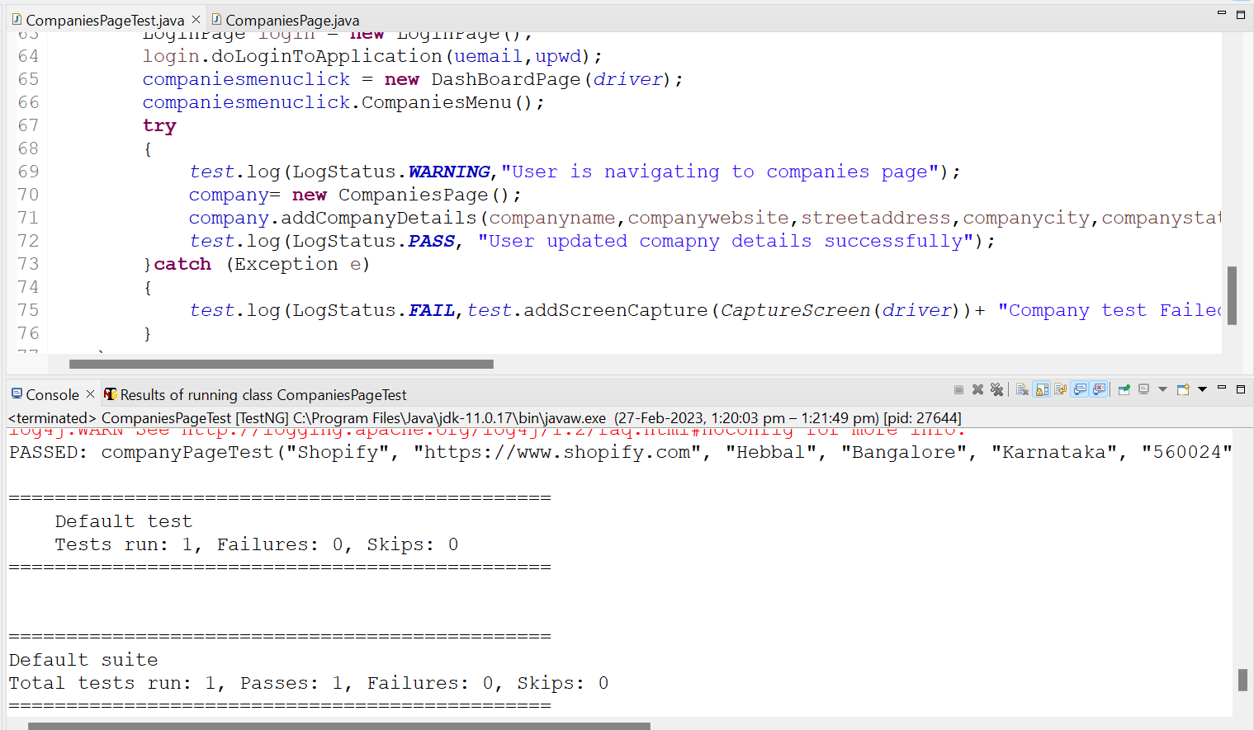

**Case 2: when mandatory field Is set to blank.**



